EXP 8

1) SELECT e.last_name, e.department_id, d.department_name

FROM employees e

JOIN departments d ON e.department_id = d.department_id;

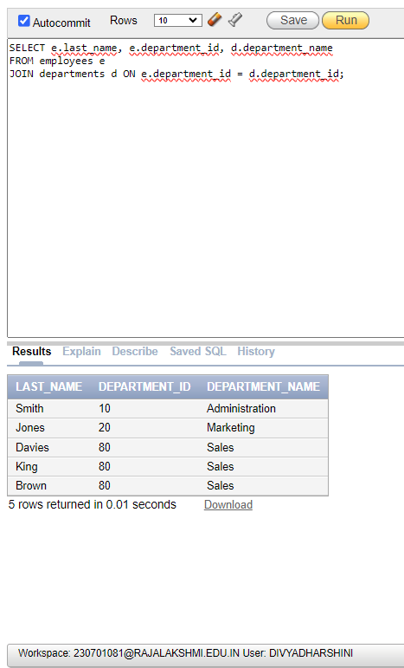

2) SELECT DISTINCT j.job_title, l.city

FROM employees e

JOIN jobs j ON e.job_id = j.job_id

JOIN departments d ON e.department_id = d.department_id

JOIN locations l ON d.location_id = l.location_id

WHERE e.department_id = 80;

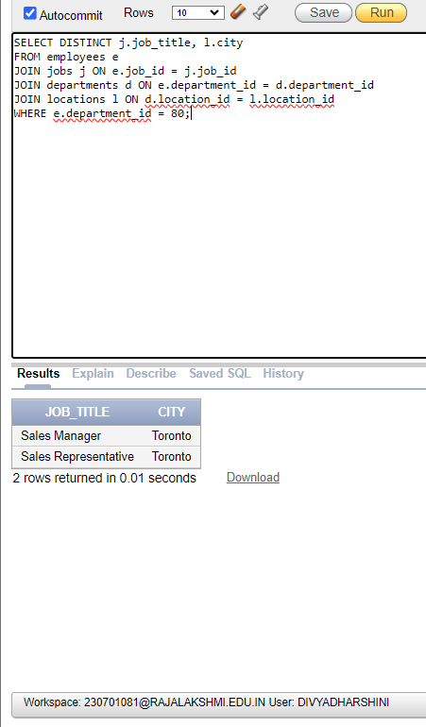

3) SELECT e.last_name, d.department_name, d.location_id, l.city

FROM employees e

JOIN departments d ON e.department_id = d.department_id

JOIN locations l ON d.location_id = l.location_id

WHERE e.commission_pct IS NOT NULL;

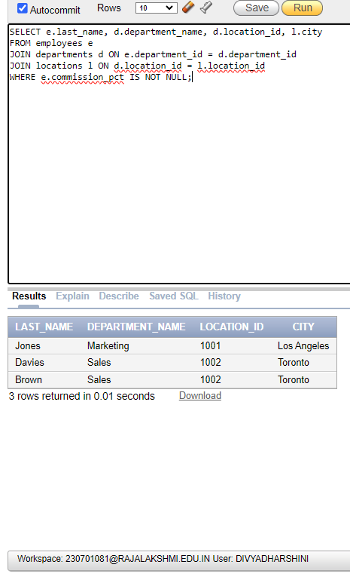

4) SELECT e.last_name, d.department_name

FROM employees e

JOIN departments d ON e.department_id = d.department_id

WHERE e.last_name LIKE '%a%';

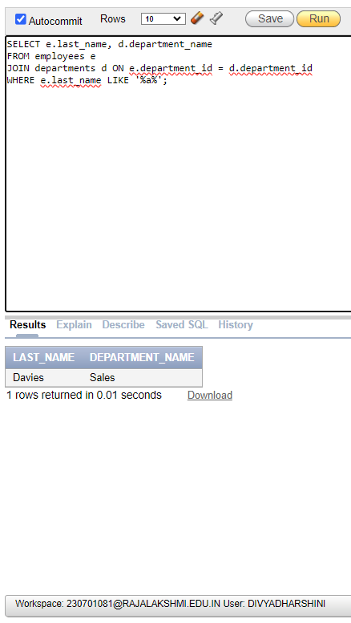

5) SELECT e.last_name, j.job_title, e.department_id, d.department_name

FROM employees e

JOIN jobs j ON e.job_id = j.job_id

JOIN departments d ON e.department_id = d.department_id

JOIN locations l ON d.location_id = l.location_id

WHERE l.city = 'Toronto';

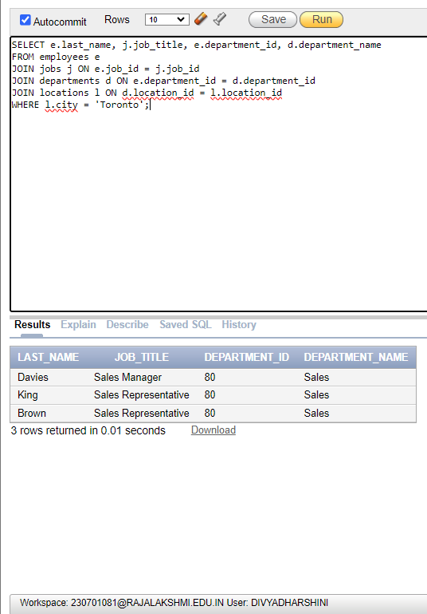

6) SELECT e.last_name AS Employee, e.employee_id AS Emp#, m.last_name AS Manager, e.manager_id AS Mgr#

FROM employees e

LEFT JOIN employees m ON e.manager_id = m.employee_id;

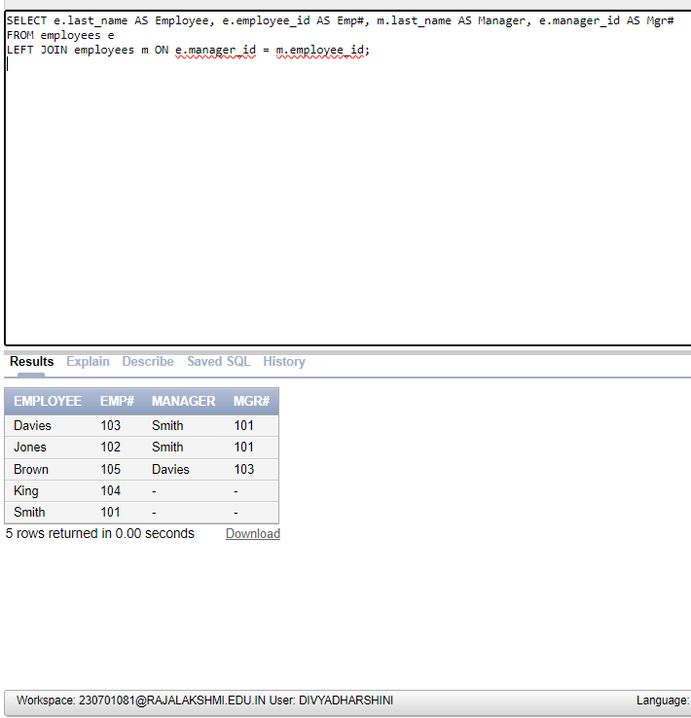

7) SELECT e.last_name, e.employee_id, COALESCE(m.last_name, 'No Manager') AS Manager

FROM employees e

LEFT JOIN employees m ON e.manager_id = m.employee_id

ORDER BY e.employee_id

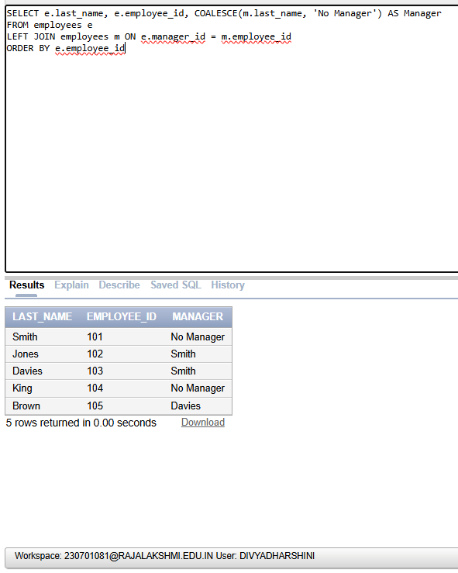

8) SELECT e1.last_name AS Employee, e1.department_id, e2.last_name AS Colleague

FROM employees e1

JOIN employees e2 ON e1.department_id = e2.department_id

WHERE e1.last_name = 'Jones' AND e1.employee_id != e2.employee_id;

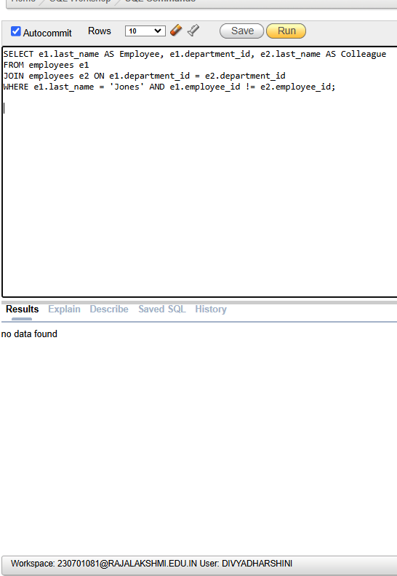

9) DESCRIBE job_grades;

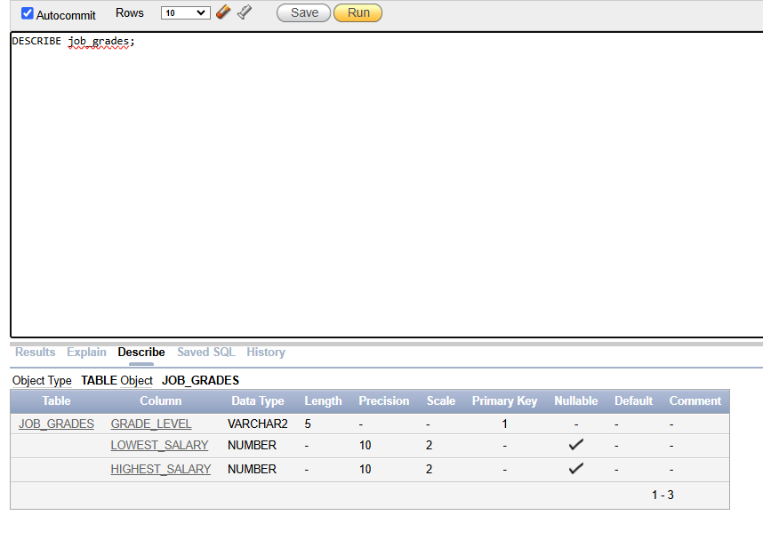

SELECT e.last_name, j.job_title, d.department_name, e.salary, g.grade_level

FROM employees e

JOIN jobs j ON e.job_id = j.job_id

JOIN departments d ON e.department_id = d.department_id

JOIN job_grades g ON e.salary BETWEEN g.lowest_salary AND g.highest_salary;

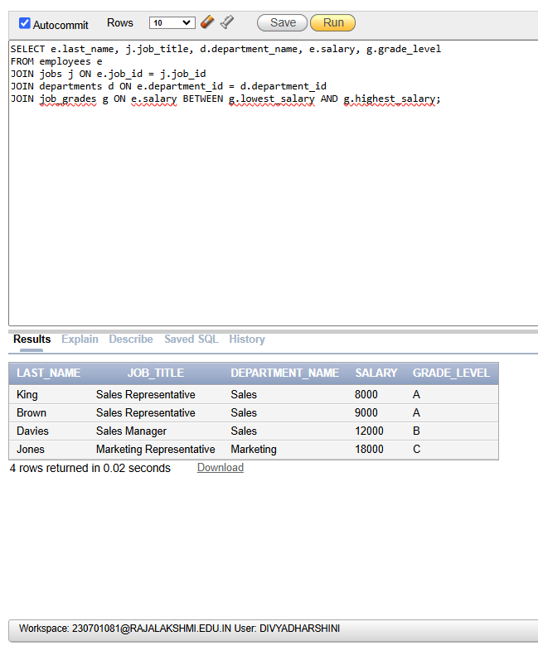

10) SELECT e.last_name, e.hire_date

FROM employees e

WHERE e.hire_date > (SELECT hire_date FROM employees WHERE last_name = 'Davies');

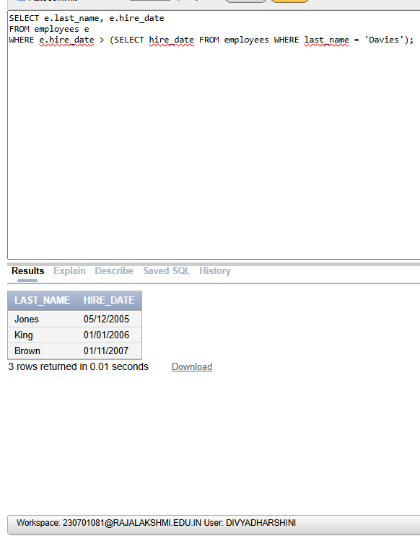

11) SELECT e.last_name AS Employee, e.hire_date AS

Emp_Hired, m.last_name AS Manager, m.hire_date AS Mgr_Hired

FROM employees e

JOIN employees m ON e.manager_id = m.employee_id

WHERE e.hire_date < m.hire_date;

